VySkan
Product Name | Micro-Concealed Asset Tracker
Product Model | VA-Tube
Hidden in Liquid. Guarding the Invisible. 1000+ Days Battery Life.
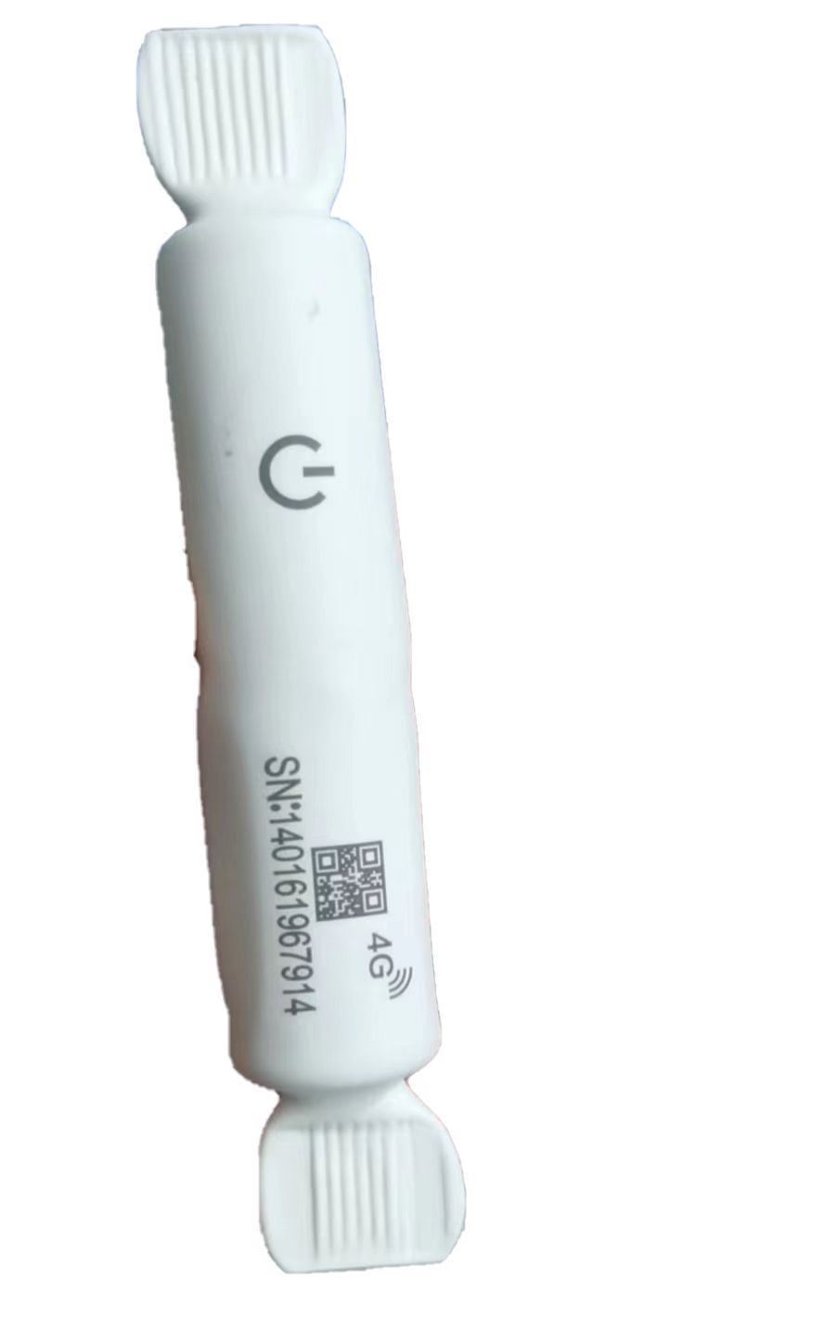
The Vyskan VA-Tube is a highly concealed, wire-free asset tracking terminal. It features the smallest volume among products with similar performance specifications, making it exceptionally easy to hide during installation. Equipped with a built-in high-capacity disposable Li-SOCl2 battery , it delivers ultra-long working times, capable of operating for over 1000 days under a 48-hour reporting interval with WIFI positioning prioritized. It completely eliminates the need for frequent battery replacements and connecting wires.
- Core Advantages
- Ultimate Concealment
The device measures only 128*18*18, making it the smallest in its class. It is specifically designed for hidden installations to prevent removal. It can even be installed directly inside a car's windshield wiper fluid tank.
- Ultra-Low Power Consumption & Long Life
The built-in 3V 1500mAh Li-SOCl2 battery features an ultra-low self-discharge rate of less than 1% per year at 25℃. In sleep mode, the operating current drops below 20uA, ensuring long-term operation.
- Tri-Mode Positioning
Supports EPO, LBS, and WIFI positioning modes. The terminal defaults to WIFI positioning priority; if WIFI enters a blind spot, it automatically switches to LBS for reference positioning.
- Wide Temperature Adaptability
Unlike standard lithium batteries limited to 0℃～70℃, this device operates reliably in extreme temperatures ranging from -30℃ to 80℃.

- Target Applications
- Covert Vehicle Tracking: Can be securely hidden in windshield wiper fluid tanks, under front/rear windshield trim panels, or within the dashboard (non-metallic areas).
- Long-Term Asset Monitoring: Ideal for unpowered assets requiring years of tracking, supporting up to 540 days of operation at a 24-hour reporting interval.
- Technical Specifications
Category | Specification | Description
Dimensions | 128*18*18 | Ultra-slim design for maximum stealth.
Weight | 60g | Lightweight build.
Primary Battery | 1500mAh (3V Li-SOCl2 Battery) | Disposable industrial-grade battery with ultra-low self-discharge.
Power Consumption | Average working current <35~60mA@3V;  Sleep current <20uA | Extreme power-saving mode.
Network | 4G Full Netcom | Reliable broadband connectivity.
Positioning Frequencies | WIFI L1: 1575.42MHz, C/A Code BD B1: 1561.098MHz | WIFI range: 2.4 GHz~2.5 GHz.
Operating Temp. | -30℃ to 80℃ | Extremely wide temperature adaptability.
Relative Humidity | 5% to 95% | High resilience in various environments.

- Smart Operating Modes
- Alarm Clock Mode: Terminals can be configured with up to 4 wake-up time points for precise positioning and server connection.
- Weekly Mode: Users can set a specific time and select one or multiple days of the week to send location data before returning to sleep.
- Blind Zone Compensation: Automatically saves trajectory data at set intervals when entering GPRS blind zones and uploads the data once back online.
- Battery Level Detection: Uploads real-time battery status with location data, displayed as a percentage and battery icon on the backend platform.
- Built for Rapid Deployment & Integration
- Wire-Free Installation: Designed to be easily installed without any connection wires. It can be secured using strong double-sided tape or strong magnets.
- Platform Integration: The platform features dedicated commands that can be pre-configured and automatically issued when the terminal comes online, improving efficiency.
- A personalized service prepared for you
- 1× Tracker Sample (Pre-configured)
- Full API & Protocol Documentation
- 1-on-1 Technical Support from our Field Engineers
- Contact us
Website: https://vyskan.com/
Email: marketing@vyskan.com

